Larry Sanders
6700 N. Agnes Ave
Gladstone, MO 64119
(816) 914-4182
ljs@xlibrisinsanity.com
September 9, 2011
Attached please find a copy of my resume.
I have a wide degree of knowledge regarding Windows Desktop and Server Operating Systems and ancillary Windows-based operations. Recent Prove-It test scores place me in the 90th percentile for Windows Server 2008 Administration and in the 86th percentile for Active Directory. I have exceptional social skills and provided an excellent technical interface between Information Technology and the user for more than 20 years. I can provide excellent personal and professional references upon request.
Given my skill set and experience my salary expectations are approximately $50,000.00.
I hope you will look upon my resume with the above information in mind. I am ready to provide solid, excellent technical and social skills to your job requirements.
Thank you for your time and consideration.
Sincerely,
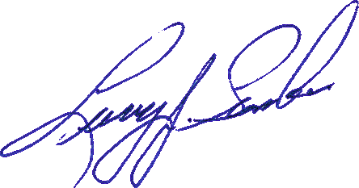
Larry Sanders

Larry J. Sanders

Professional Summary:

Over 20 years of experience in Windows Systems Administration, Support and Infrastructure .

Education & Certifications:

Eldorado College-Oceanside, CA
BS, Business Administration

MCP Windows XP Professional (Current)
CompTIA A+ Certification (current)
Novell Netware CNE386 (expired)

Technical Skills:

Windows 3.11/95/98/98/SE/ME/XP Professional/Vista/7, Migration from XP to Win 7, Novell 3.11, 4.2, Windows Server 2003, Windows Server SBS 2003 w/Exchange, Active Directory, Windows Server 2008 SP2, R2, IIS 6.0/7.0, Sharepoint 2007, Hyper-V, Dynamic Quest and other ticketing apps, Word, Excel, Outlook, PhotoShop, Filezilla FTP, VPN (Cisco & Shrew), ISA, PCI, PC Card, 802.11a,b,g Fast, WiFi and Gigabit Ethernet NIC installation and communications, Hubs, switches, routers, backup tape, hard drives, RAID 0, RAID 1, RAID 0+1 and RAID 5

Professional Experience:

BE Aerospace-Lenexa, KS 10/10 to 07/11
Systems Administrator (contract)
- Sole support provider for 390+ desktops, 100+ printers, Windows deployments servers for 550 Windows/Citrix users.
- Duties include network troubleshooting, all desktop issues both hardware and software. Configuring and maintaining Smartphones (primarily BlackBerry Bold series)
- Migration of Windows XP Pro users to Windows 7 Professional
- Also image and install new computers, join to the Active Directory Domain, maintain and troubleshoot plant wide wireless installation and daily backups.

Codero/Aplus.net-Overland Park, KS 2/08 to 4/10
Windows Administrator, Level II
- Responsible for installing, configuring, and maintaining Windows Server 2003 and IIS 6.0 servers and also Windows Server 2008 and IIS 7.0 servers.
- Provided IT support internally for more than 200 local users.
- Migration of Windows XP Pro users to Windows 7 Professional
- Provided Level II support for over 20K hosted Windows websites using Active Directory IIS 6.0 & IIS 7.0.
- Supported Windows XP Profession SP3, Vista Ultimate SP2 and Windows 7 (32 & 64-bit) operating systems.
- Managed migration of 85 Sharepoint 2003 users from old to Domain name to a new Domain name under Sharepoint 2007.
- Managed company-wide backups of host and production servers and all network shares.
- Built new PCs as required for new users and replacement PCs.
- Provided the initial network setup and orientation for the users.
- Administered security cameras and archived the subsequent images.
- Responsible for the setup, tear down and maintenance of A/V equipment used in company-wide meetings.

Comfort Products Distributing, Inc.-Lenexa, KS 11/05 to 2/08
Senior Desktop Support
- Supported 255 users in 11 wide-area locations, directly responsible for two on-site servers (Windows 2000 and AIX 4.0) as well as WAN routers and digital phone system.
- Add and delete users in Windows and AIX (Unix), adjust security levels, build termination packages.
- Maintain Exchange service and Outlook users.
- Primary area of responsibility was in a Helpdesk capacity responding to email and telephone requests.
- Problem resolution via email, telephone, Remote Desktops and UltraVNC remote software.
- Migrated system from static IP addressing to V-LAN DHCP.

Blake & Uhlig, P.A.-Kansas City, KS 1996 to 2005
System Administrator
- Supported 30+ Attorneys, Secretaries and Paralegals.
- Upgraded server hardware and OS three times beginning with Novell 3.11 and ending with Windows Server 2003, SP1.
- Replaced thinwire BNC Ethernet infrastructure with Fast Ethernet.
- Upgraded workstations from DOS 6.1/Win 3.11 to Windows XP Professional.
- Managed and maintained PC based PBX phone system from DASH/Picazo.
- Established Internet/E-Mail service, maintained virus filters/trapped infected e-mail, built PCs from scratch, converted DOS based programs to MS Access, and maintained backups.

Commerce Bank-Kansas City, MO 1992 to 1996
Network Systems Specialist
- Responsible for the operation of 8 Novell 3.11 servers and their approximate 550 end-users.
- Duties included on-site round the clock (24/7) support to the servers and business hours support for the users.
- Support to the end user was comprehensive, from break-down of the Token-Ring network to simple end user failure.
- Member of the committee to establish the first Class A TCI/IP addressing schema for LAN/WAN and Internet communication.

Contact Information:

Larry Sanders
6700 N. Agnes Ave.
Gladstone, MO 64119

Cell - (816) 914-4182
Email: - ljs@xlibrisinsanity.com

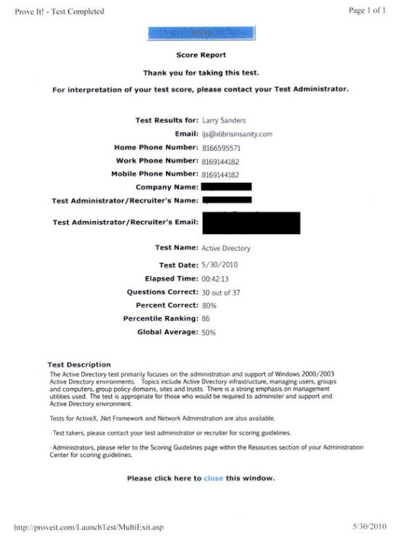

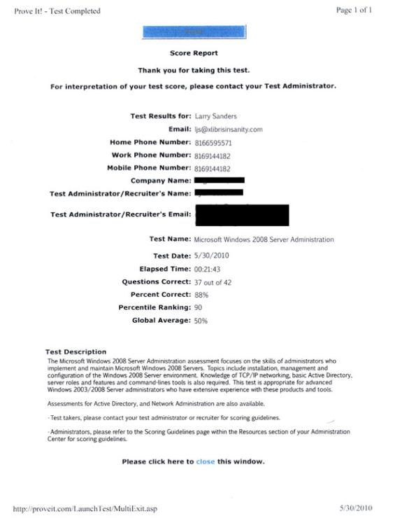

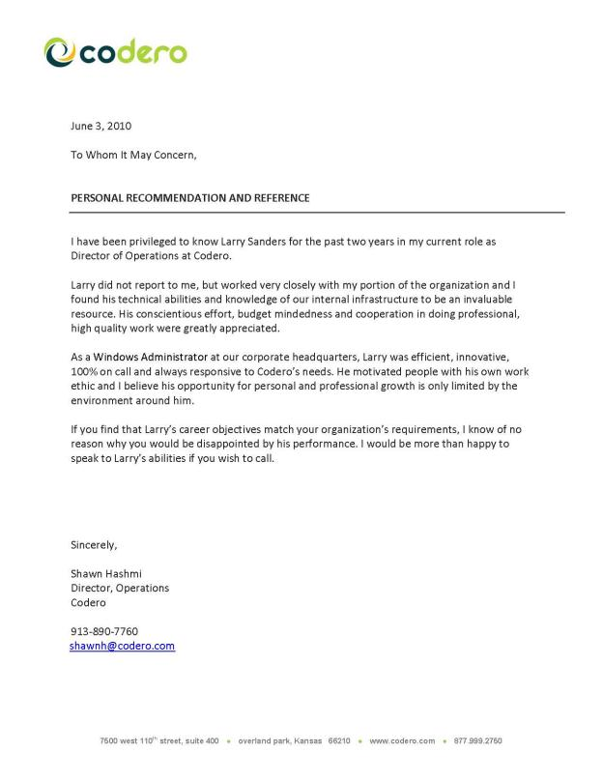
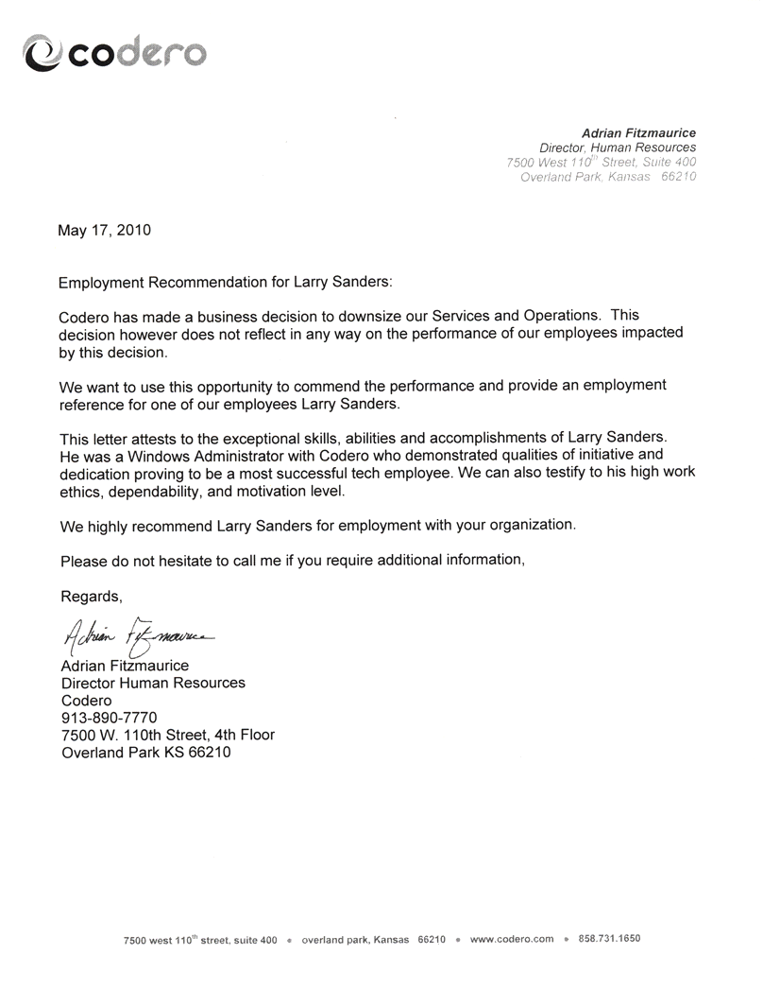

Larry Sanders
6700 N. Agnes Ave
Gladstone, MO 64119
(816) 659-5571 - Home
(816) 914-4182 - Cell
ljs@xlibrisinsanity.com
References

Ryan Elledge
Chief Operating Officer
Codero, LLL
7500 W. 110th Street
Overland Park, KS 66210 (913) 890-7700
ryane@codero.com

Shawn Hasmi
Director of Operations
Codero, LLC
7500 W. 110th Street
Overland Park, KS 66210 (913) 890-7761
shawnh@codero.com

Nicholas Gaugler
Vice President, Engineering
Codero, LLC
7500 W. 110th Street
Overland Park, KS 66210 (913) 890-7772
nickg@codero.com

Ralph Munyan
Vice President and General Counsel
Codero, LLC
7500 W. 110th Street
Overland Park, KS 66210 (913) 890-7787
ralphm@codero.com

Adrian Fitzmaurice
Director, Human Resources
Codero, LLC
7500 W. 110th Street
Overland Park, KS 66210 (913) 890-7770
adrianf@codero.com

